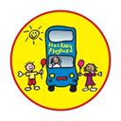

Hackney Playbus Referral Form
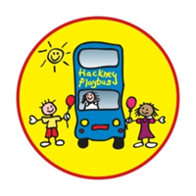
Hackney Playbus is a local charity aimed at supporting vulnerable families in and around Hackney. Our programme encourages healthy bonds between parents and child, positive parenting, helps to reduce social isolation, build community cohesion and supports parents to engage with public services.
In-keeping with the requirements of the Data Protection Act 1998 Hackney Playbus adheres to legislation ensuring all personal data is collected with consent, whilst also being stored and handled securely.
Name: | DOB:
Address: | Telephone Number:
Email: | NHS Number: (if known)
DOB of all Children: Gender of Children:

Is the family aware the referral is being made?
Does the family give their consent to be contacted?
Referral Agency: | Contact Name and Job Title:
Contact Details: | Date of Referral:
How did you hear about the project:

Why is this referral being made?:

Is it safe to leave a message on an machine or a text message:
Yes/No
Any Safeguarding concerns or potential risk to service user or group members engaging with service:

Has a risk assessment been Carried out?
If yes, please provide a copy.
Are other professionals/services currently involved with family:
Yes/No
Contact name and details:

Any additional information:

Are you aware if the parents or children have HIV: Yes / No

Asian or Asian British – Pakistani |  | Mixed White and Black Caribbean
Asian or Asian British – Bangladeshi |  | Mixed White and Asian
Any other Asian background |  | Any other mixed background
Black or Black British – African |  | Somali
Black or Black British – Caribbean |  | Turkish/Kurdish
Any other Black background |  | Vietnamese
Chinese |  | White British
Jewish Orthodox |  | Australasian
Mixed White and Black African |  | Any other White background

Please return the form to:
Vanessa Kirkpatrick
Hackney Playbus Referral Pathway Manager, 8-9 Kingsmead Way, London, E9 5QG
Email: vanessa@hackneyplaybus.org, Office: 0208 510 3335

